Create an Android project

This lesson shows you how to create a new Android project with Android Studio, and it describes some of the files in the project.

To create your new Android project, follow these steps:

1. Install the latest version of [Android Studio](https://developer.android.com/studio/).
2. In the **Welcome to Android Studio** window, click **Start a new Android Studio project**.

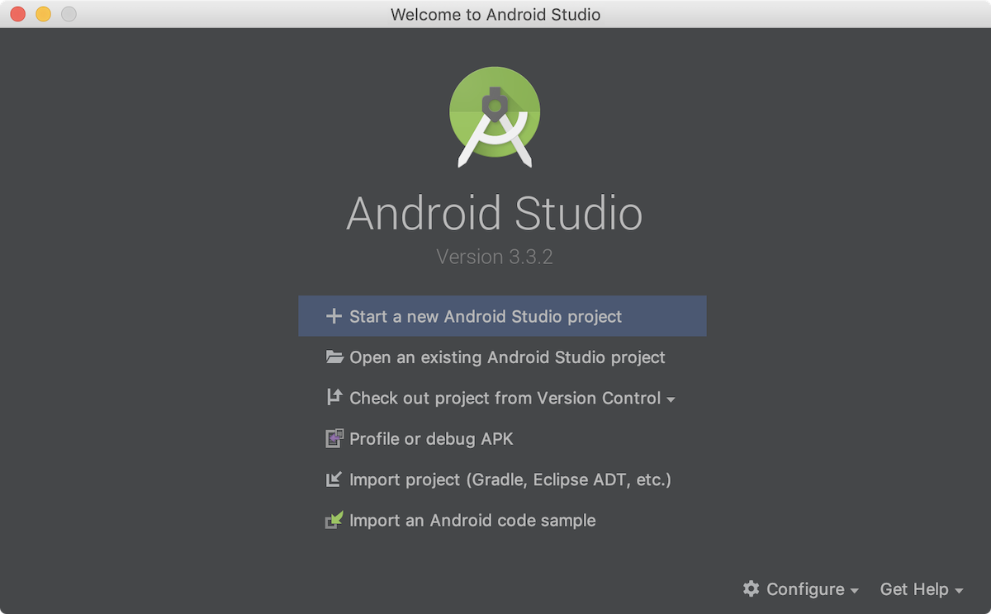

**Figure 1.** Android Studio welcome screen

If you have a project already opened, select **File > New > New Project**.

1. In the **Choose your project** window, select **Empty View Activity** and click **Next**.

1. In the **Configure your project** window, complete the following:
   * Enter "HelloWorld" in the **Name** field.
   * Enter "com.example.myfirstapp" in the **Package name** field.
   * If you'd like to place the project in a different folder, change its **Save** location.
   * Select either **Java**  from the **Language** drop-down menu.
   * Leave the other options as they are.

1. Click **Finish**.

After some processing time, the Android Studio main window appears.

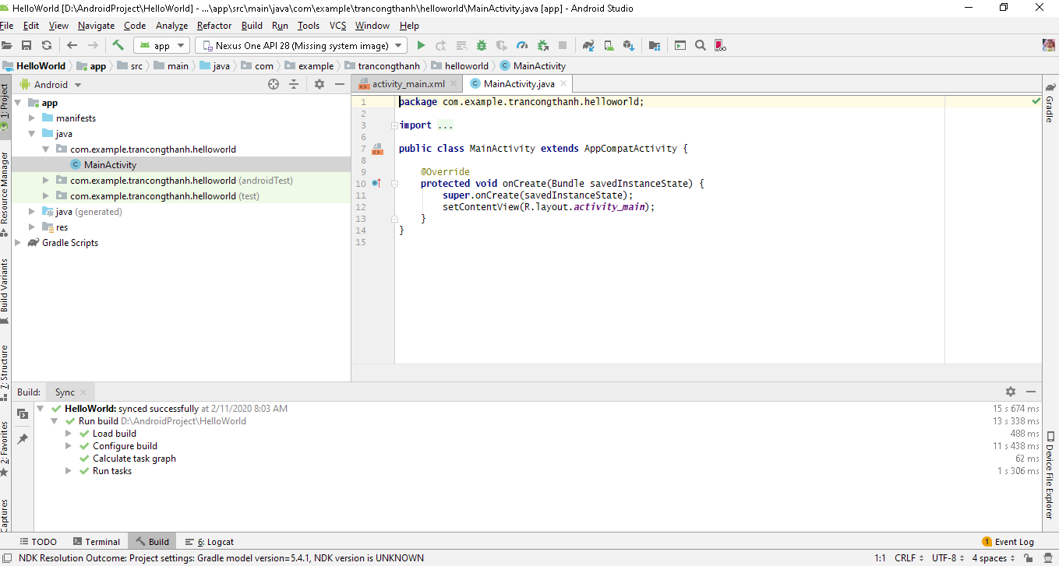

6. **Run** 🡪 **Run ‘app’**

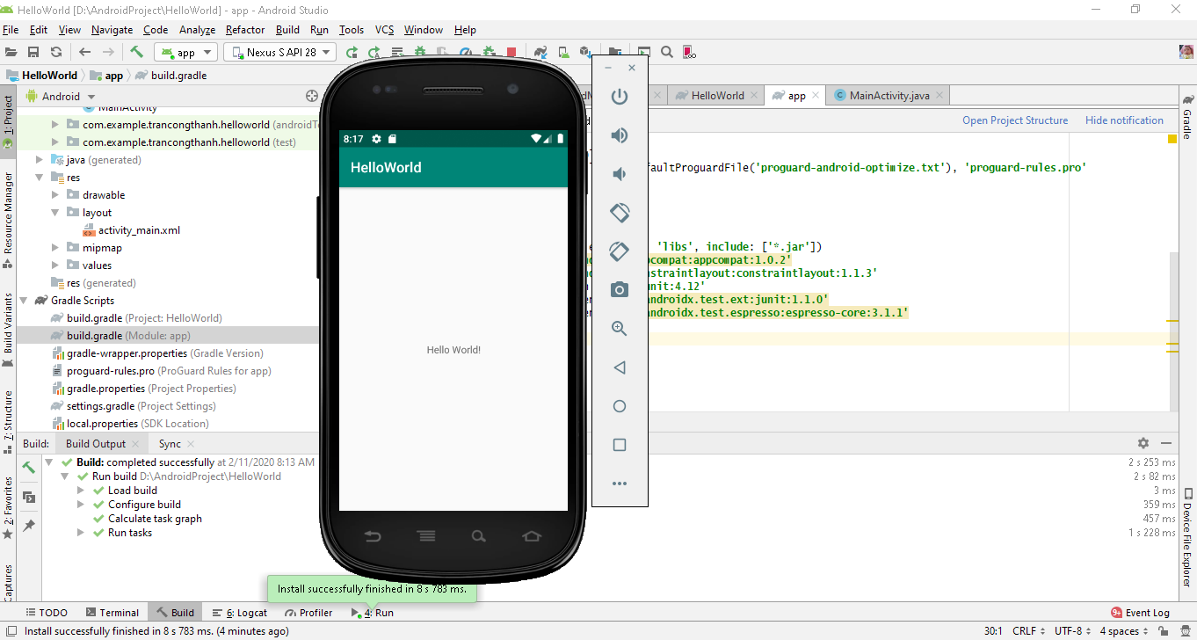

**Sinh viên tham khảo thêm tại** <https://developer.android.com/training/basics/firstapp>